**Scatter Graphs**

*Plotting points on a scatter graph*

Below are the marks of eight students in their Maths and Science tests. Plot the points on the scatter graph underneath.

|  |  |  |  |  |  |  |  |  |
| --- | --- | --- | --- | --- | --- | --- | --- | --- |
| Student | A | B | C | D | E | F | G | H |
| Maths mark | 56 | 73 | 51 | 62 | 24 | 67 | 94 | 35 |
| Science mark | 62 | 68 | 45 | 68 | 35 | 73 | 88 | 32 |

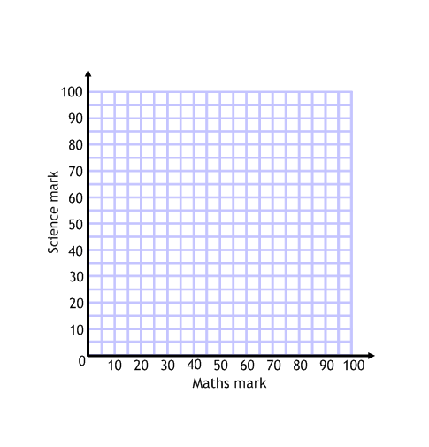

*Have a go at these two scatter graphs:*

The data below shows the number of scarves sold by a shop in a week and the temperature that day:

|  |  |  |  |  |  |  |  |
| --- | --- | --- | --- | --- | --- | --- | --- |
| Day of the week | M | T | W | T | F | S | S |
| Sales of scarves | 73 | 56 | 54 | 38 | 7 | 39 | 82 |
| Temperature (⁰C) | 9 | 13 | 15 | 19 | 25 | 12 | 5 |

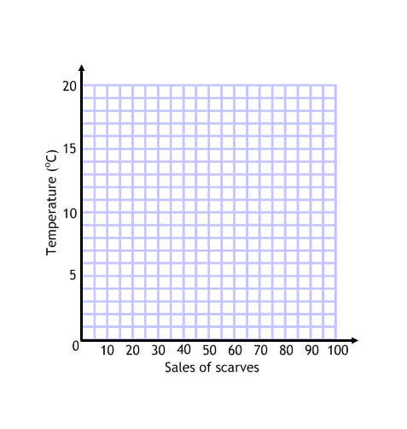

The data below shows the amount of petrol used by a car and the distance driven on eight different journeys:

|  |  |  |  |  |  |  |  |  |
| --- | --- | --- | --- | --- | --- | --- | --- | --- |
| Journey | 1 | 2 | 3 | 4 | 5 | 6 | 7 | 8 |
| Distance (km) | 75 | 140 | 237 | 180 | 20 | 93 | 104 | 42 |
| Petrol used (l) | 7 | 12.5 | 25.3 | 16 | 3.5 | 8.9 | 9.5 | 4.1 |

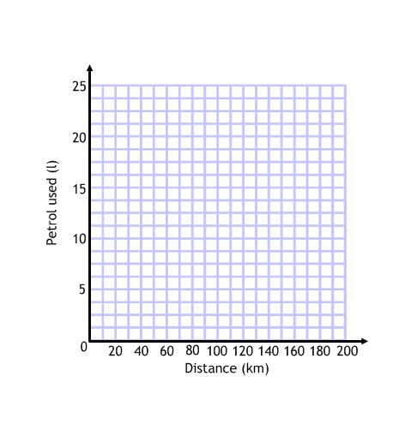

*Correlation*

What do you think would be the correlation of these sets of data?

1. The sales of ice creams as the temperature rises during the summer.
2. The value of a mobile phone as it gets older.
3. The amount you'll get in a maths test the further you live from school.

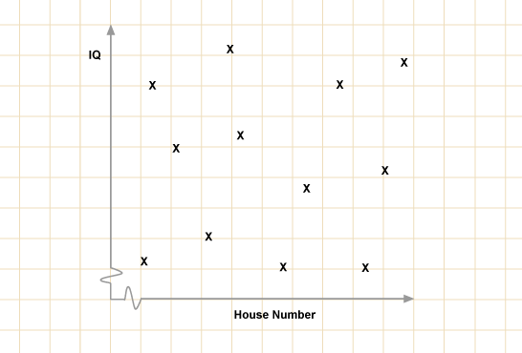 ………………………………………………

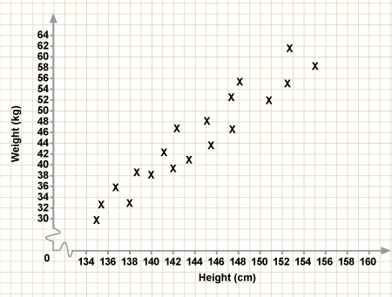 ………………………………………………

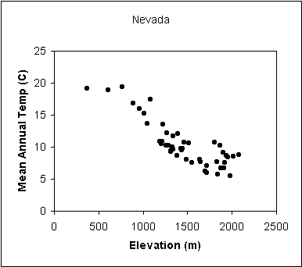 ………………………………………………

*Draw the scatter graph and describe the correlation:*

Below are listed some test marks for 8 students. Plot them on the scatter graph and describe the correlation.

|  |  |  |  |  |  |  |  |  |
| --- | --- | --- | --- | --- | --- | --- | --- | --- |
| Student | A | B | C | D | E | F | G | H |
| Maths mark | 56 | 73 | 51 | 62 | 24 | 67 | 94 | 35 |
| Art mark | 54 | 43 | 47 | 44 | 82 | 31 | 18 | 87 |

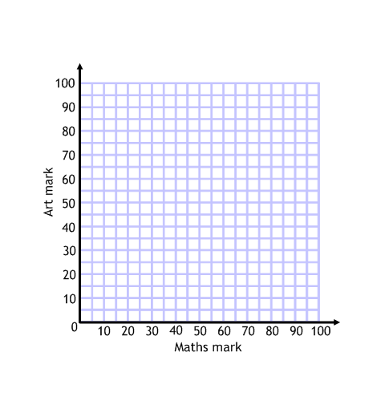

The data has ………………………………………………………………… correlation.

*“Line of best fit” and estimating results*

Estimate, using your graph, how many scarves the shop would sell when the temperature was 7oC.

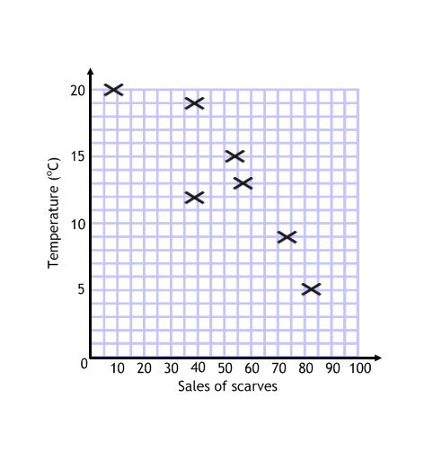

Number of scarves: ……………………………………………………

Estimate, using your graph, how many litres of petrol the car would use on a journey of 160km.

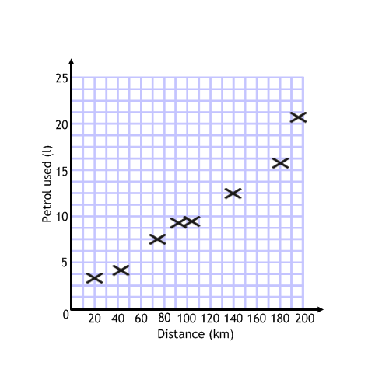

Number of scarves: ……………………………………………………